**Supplementary Table 1: Glasgow coma scale (GCS)1**

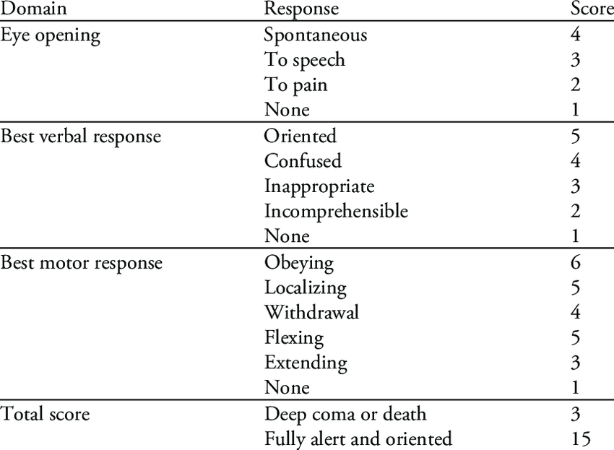

The GCS is scored between 3 and 15, 3 being the worst and 15 being the best. It is composed of three parameters: best eye response (E), best verbal response (V), and best motor response (M). The components of the GCS should be recorded individually; for example, E2V3M4 results in a GCS score of 9. In the setting of head trauma, a GCS score of 8 or less measured on admission represents severe traumatic brain injury (TBI).

Traditionally, a GCS score of 9 through 12 has represented moderate TBI, and a GCS score of 13 through 15 mild TBI. However, the recognition that more than one-third of patients with TBI and a GCS score of 13 have potentially life-threatening intracranial lesions has led to a reevaluation of this classification. While a revised classification has not been widely adopted, a GCS score of 9 through 13 likely best represents the TBI population at moderate risk for death or long-term disability [1].

**Supplementary Table 2: Overview of the Criteria for the Categories of the Glasgow Outcome Scale-Extended score (GOS-E)2.**

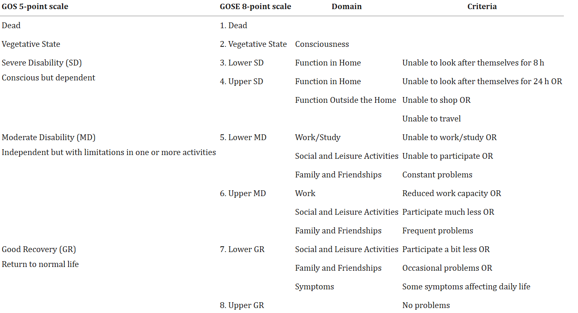

GOSE, Glasgow Outcome Scale-Extended; GOS, Glasgow Outcome Scale.

Referances

1. Godoy DA, Aguilera S, Rabinstein AA. Potentially severe (moderate) traumatic brain injury: A new categorization proposal. Crit Care Med 2020; 48:1851.

2. Wilson L, Boase K, Nelson LD, Temkin NR, Giacino JT, Markowitz AJ, Maas A, Menon DK, Teasdale G, Manley GT. A Manual for the Glasgow Outcome Scale-Extended Interview. J Neurotrauma. 2021 Sep 1;38(17):2435-2446. doi: 10.1089/neu.2020.7527. Epub 2021 Apr 6. PMID: 33740873; PMCID: PMC8390784.